
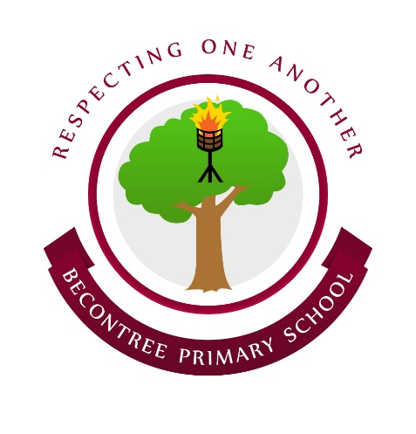
SCHOOL COUNCIL
VotesforSchools Topics!


Your Vote Counts

Last week School Councillors agreed to have National and International topics/news discussed in school.

Results were as follow:-

16 4
(80%) (20%)

