Schools are closing for some time – how can I help my child learn English at home?
Online learning
You don’t want your child to spend all day on a laptop, tablet or smart phone but there are some good websites that will help them learn English – so 30 minutes to 1 hour of online learning is good!

- Learning Village – if your child has a log-in, they can use a tablet to carry on using Learning Village at home. Just 30 minutes a day will make a big difference. https://www.learningvillage.net/user/login
- British Council Learn English Kids: https://learnenglishkids.britishcouncil.org/ The ‘Listen and watch’ section is very good, especially the stories you can listen to, read and watch.
- British Council Learn English Teens: https://learnenglishteens.britishcouncil.org/ The ‘Skills’, ‘Grammar’ and ‘Vocabulary’ sections are very good for older children.
- Cbeebies (the games are good!): https://www.bbc.co.uk/cbeebies/games
- Bitesize: https://www.bbc.co.uk/bitesize Just click on the right age-group to see the learning resources


Reading
Get your child to read a little bit every day. They can read in English or in their first language as, if they can read well in their first language, this will help them learn to read in English. If you don’t have many books, get them to read their favourite book out loud so they can concentrate on reading with expression and making it sound interesting.

Watching TV and films
We don’t want children to have too much screen time but an hour or so a day of watching quality TV can really help their language skills. We recommend:
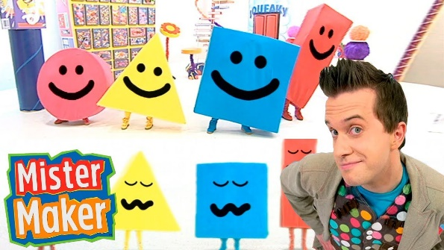
- CBeebies – most programmes are good for children up to the age of 6
- CBBC – most programmes are good for children of all ages (including ‘big kids’ over the age of 18!)
- Films – if your child can read in their first language, they could watch films with subtitles (most Disney films are good for developing language). If they can’t read in their first language, they could watch a favourite film dubbed into their first language and then watch it again in English.
Learning new words in English
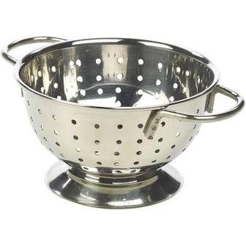
- Around the house – name as many objects as you can in English and then try to describe them, e.g. a hard shiny colander, a soft fluffy blanket. Try to find out the names of any objects you don’t know.
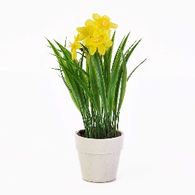
- Out the window – do the same thing looking outside. If you have a garden, see how many things you can name and describe. Get outside and get active if you can!
Keep lists of any new words that you learn and practise them together. It can be surprising how many everyday objects you don’t know the names of, even if your English is good!

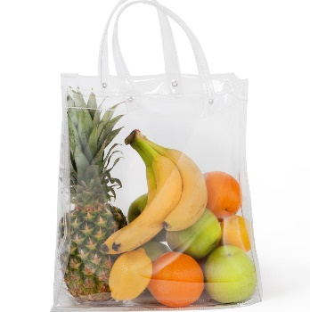
Playing memory games
Play ‘I went to the shops and bought a …’ Think of something you can buy, e.g. an apple. Your child then repeats what you have said and adds something else:
- Parent (or brother/sister): I went to the shops and bought a banana.
- Child: I went to the shops and bought a banana and an apple.
- Parent (or brother/sister): I went to the shops and bought a banana, an apple and a carrot.
- Child: I went to the shops and bought a banana, an apple, a carrot and a tin of beans.
See if you can keep going!


Writing – some ideas
Even just a few minutes of writing every day will help your child remember how to write in English. If your child can write in their first language, they might want to do that first and then translate into English.
They could:
- Keep a diary – include simple things like what the weather was like, what they had to eat, what they watched on TV etc.
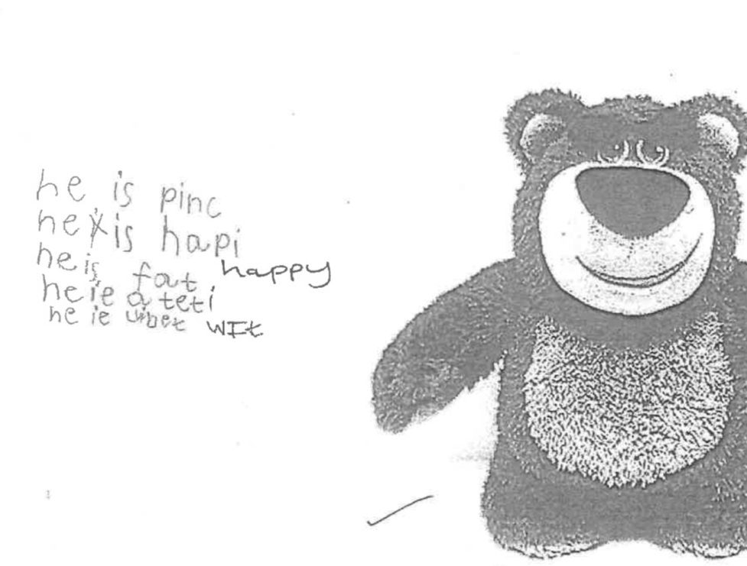
- Describe pictures – look through newspapers, books and magazines to find interesting pictures to write about
- Write stories based on their favourite books and films
If your child has very little English, they could draw pictures and talk about them in their first language before trying to write.

