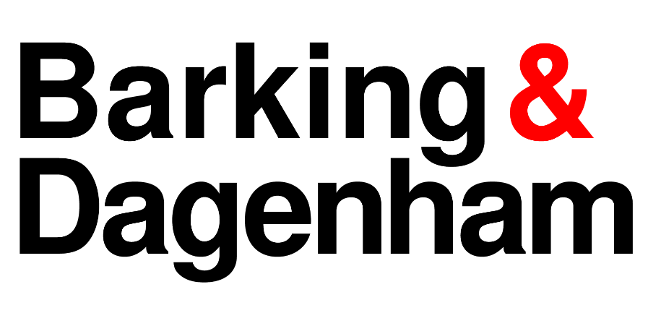 | 

DIRECTORS’ REPORT
ALL SCHOOL GOVERNING BOARDS
SPRING TERM 2025
This term’s report is prepared by BDSIP for the London Borough of Barking and Dagenham, and includes the following items:

For Action
- Review of LBBD Suspensions and Exclusions in the Autumn Term of 2024/25
- Summary of Barking and Dagenham Schools’ Results 2024 – Secondary update

For Information
- Annual Education Performance Review for Academic Year 2023/24
- London Governors’ Newsletter Spring 2025

Elaine Allegretti, Director of People and Resilience
& Jane Hargreaves, Commissioning Director Education

For Action:

1 | Review of LBBD Suspensions and Exclusions in the Autumn Term of 2024/25

Introduction
This report provides a summary of the exclusion data for primary, secondary, and special schools in the London Borough of Barking and Dagenham (LBBD) for the Autumn term of the 2024/25 academic year. It outlines the measures being taken by the Local Authority to address the issues and provides recommendations for governors.
Primary School Exclusions
The primary school exclusion rates for Autumn 2024/25 indicate that the overall rate for primary suspensions is 0.22, which is consistent with previous rates and remains below the national average. However, the permanent exclusion rate is 0.02, which is notably high due to six permanent exclusions having been carried out. One of these exclusions has been rescinded, bringing the total to five.
Secondary School Exclusions
The overview of secondary school exclusion rates shows that the permanent exclusion rate is 0.04, slightly higher than in previous years but still below the national average. The suspension rate stands at 1.68, which has remained stable since 2018-2019 and is below the national average.
Special Schools and Alternative Provisions
There are high suspension rates in special schools and alternative provisions. Despite the high suspension rate, the average number of days lost per suspension is low when compared to mainstream schools. The Local Authority plans to address this issue in future visits and reports.
Local Authority Measures to Address Exclusion Issues
The Local Authority is implementing several measures to support schools to aid the reduction of suspensions and prevent future permanent exclusions where possible:
- The use of the Education Inclusion Partners to review and monitor children at risk of exclusion and the review of cases to ensure evaluation and learning.
- A survey with primary schools on de-escalation narratives and positive handling practices to better understand and mitigate suspension and exclusion causes.
- The development of interventions, alternative provisions and nurture programs to offer supportive learning environments for children.
- Regular signposted training opportunities for school leadership and governors on both exclusion and inclusion to ensure all staff are well-informed and equipped to handle exclusion-related issues appropriately.

Recommendations for Governors:
To support these measures, it is recommended that governors:
- Governors and school leadership participate in the training opportunities provided by the Local Authority on exclusion and inclusion practices.
- Encourage the use of the local authority Inclusion service via the area ‘Education Inclusion Partners’ to gain insights and feedback on exclusion cases.
- Promote the development and implementation of de-escalation narratives and positive handling practices within schools to reduce risk and escalation in behaviour.
- Support the use of interventions and alternative provisions to provide additional support to children at risk of exclusion.
- Regularly review the exclusion data, with focus on a range of pupil groups, and monitor the effectiveness of the measures implemented to ensure continuous improvement and inclusion within our mainstream and special settings.
- Attend the planned Governors’ training on 22nd January 2025. This will be via Zoom and is available, free of charge for all Governors and school staff.

Contact Officer:
Mark Aspel  Head of Inclusion |  |  | Mark.Aspel@lbbd.gov.uk

2 | Summary of Barking and Dagenham Schools’ Results 2024 – Secondary update
Purpose:
The tables below provide a summary of each school and the overall Local Authority results for GCSE in 2024. All data are provisional and subject to change before revised data is published by the DfE.

Summary:
Key Stage 4 GCSE – Progress 8 LBBD

​ | B&D  2019​ | B&D  2022​ | B&D  2023​ | B&D  2024​ | National  2019
9-4 EN & MA  9-5 EN & MA​ | 61.9​  42.6​ | 68.5​  50.6​ | 66.0​  48.5​ | 65.8​  47.4​ | 64.9  43.4
Attainment 8​ | 46.5​ | 49.3​ | 48.0​ | 47.8​ | 46.8
Progress 8​ | 0.17​ | 0.13​ | 0.24​ | ​0.24 | 0.0

The government planned to bring standards in line with pre-Covid 2019 levels and individual GCSE grade boundaries were adjusted to reflect this aim. Despite a very slight dip in Attainment 8, the Progress 8 score for LBBD is in line with 2023 and is comfortably above the performance of 2019. Given the context, this is a significant achievement for schools and pupils.

Key Stage 4 GCSE – Progress 8 (Disadvantaged cohorts)
LBBD Non-Disadvantaged P8
0.43

National Non-Disadvantaged P8
0.16

National Disadvantaged P8
-0.57
School | Overall P8 score | Disadvantaged P8
All Saints | 0.72 | 0.51
Barking Abbey | 0.02 | -0.18
Brook 6th Form | -0.6 | -0.55
DPCS | -0.25 | -0.5
Eastbrook | -0.62 | -1.09
Eastbury | 0.22 | -0.07
Goresbrook | 0.87 | 0.78
Greatfields | 0.29 | -0.09
JRCS | 0.20 | -0.3
Riverside | 0.78 | 0.45
Robert Clack | 0.16 | -0.28
Sydney Russell | 0.72 | 0.4
Warren | 0.37 | -0.2

The disadvantage gap index summarises the attainment gap between disadvantaged pupils and all other pupils. A gap of zero would indicate that there is no difference between the average performance of disadvantaged and non-disadvantaged pupils.

The Progress 8 score for most schools in LBBD is above 0 and also above the national Progress 8 score for non-disadvantaged pupils (0.16). The disadvantaged Progress 8 score of 92% of schools in LBBD is also above the national disadvantaged score of -0.57.

Key Stage 4 GCSE – Progress 8 by prior attainment cohort

 | Low | Average | High
All Saints | 0.11 | 0.86 | 0.85
Barking Abbey | -0.05 | 0.02 | 0.07
Brook 6th Form | n/a | -0.66 | n/a
Robert Clack | 0.09 | 0.19 | 0.13
DPCS | -0.15 | -0.29 | -0.3
Eastbrook | -0.3 | -0.67 | -1.15
Eastbury | 0.38 | 0.21 | -0.02
Goresbrook | 1.02 | 0.97 | 0.44
Greatfields | 0.47 | 0.34 | -0.17
JRCS | 0.26 | 0.24 | 0.05
Riverside | 0.95 | 0.82 | 0.59
Sydney Russell | 0.64 | 0.8 | 0.57
Warren | 0.27 | 0.37 | 0.5
Average | 0.36 | 0.25 | 0.06

Prior attainment bands are calculated based on pupils’ average scores in Reading and Maths at the end of key stage 2.

Rates of progress vary nationally depending on pupils’ prior attainment bandings. On average, in LBBD, pupils with low prior attainment made the most progress at GCSE from key stage 2. Pupils from high prior attainment bands make less progress and this is also reflected in national trends.

Key Stage 4 GCSE – Progress 8 by sex

 | Girls | Boys
All Saints | 0.86 | 0.63
Barking Abbey | 0.21 | -0.14
Brook 6th Form | n/a | n/a
Robert Clack | 0.32 | 0.01
DPCS | -0.24 | -0.26
Eastbrook | -0.61 | -0.64
Eastbury | 0.23 | 0.2
Goresbrook | 1.03 | 0.63
Greatfields | 0.33 | 0.26
JRCS | 0.16 | 0.24
Riverside | 0.91 | 0.64
Sydney Russell | 0.88 | 0.58
Warren | 0.48 | 0.23
Average | 0.35 | 0.19

Nationally, Progress 8 scores for girls and boys showed that girls averaged a Progress 8 score of 0.09 whereas boys averaged a Progress 8 score of -0.15. This means girls, on average, progressed more than expected when compared to similar pupils in their prior attainment group, whereas boys achieved nearly one fifth of a grade less than expected by the end of KS4.

This pattern is also reflected in the Progress 8 outcomes for schools in LBBD. It is a significant achievement that both girls and boys on average, score positive scores, there is however a gap of almost one fifth of a grade between the progress performance of the two sexes.

Recommendations:
Governors are asked to review the information provided and compare the performance and trend of their school with other local schools, the overall Local Authority position and most importantly the national figures and, where available, London. Clear evaluative comments need to be recorded for the performance of their schools in 2024.

- How do results compare with national and local averages – above, below, well above, well below, in line?
- At GCSE, are there differences in the performance of different classes or groups of pupils? Why? Can you see evidence of the impact of the school’s use of the Pupil Premium?

Contact Officer:
Jessica McQuaid  Head of Schools Performance and Partnerships |  | jessica.mcquaid@lbbd.gov.uk

Information items
1 | Annual Education Performance Review for Academic Year 2023/24
Purpose:

To share with Governors a review of the borough’s education and participation performance for 2023/24. This is a report which is submitted yearly by the Council’s Education Service to Cabinet Members.

Summary:

This report provides a detailed overview of the borough’s education and participation performance in 2023/24 in relation to the five priorities of the borough’s Education & Participation Strategic Plan 2023-26. It includes national exam and test results for the borough and key achievements and challenges across schools and education partners.
Recommendation:

Governors are asked to note the report, with a focus on the summary in particular. Please find the report with an appendix below:

- The Annual Education Performance Review 2023/24:
Education Perf 2023-24 Report.pdf

- An appended ‘Education dataset’: Ed Perf - App A Dataset.pdf

Contact Officer:
Natasha Cock  Strategy, Commissioning & Intelligence Lead, Education, LBBD |  |  | natasha.cock@lbbd.gov.uk
Background Information:

The borough’s Education & Participation Strategic Plan 2023-26
(PowerPoint Presentation) supports delivery of ‘The Barking & Dagenham Best Chance Strategy – Our partnership plan for babies, children, young people and their families, September 2022 - September 2025’.

The five priorities in the Education & Participation Strategic Plan 2023-26 are:

• A place in a good or outstanding school or setting
• Supporting achievement for all, including children exceeding national then London standards
• Strengthening outcomes, support and opportunities for vulnerable children and young people, including those with SEND
• Supporting the wellbeing and resilience of children and young people
• Improving opportunities for young people post 16 and maximising numbers who are in education, employment and training.

2 | London Governors’ Newsletter Spring Term 2025
The Spring Term newsletter produced by London Co-ordinators of Governor Services (LCOGS) is attached. This term’s report includes The Children’s Wellbeing and Schools Bill 2024, Ofsted’s new inspection approach, funding updates, and free Breakfast Clubs.

Contact Officer:
Jackie Day  Governor Services Manager |  | 07866 912860 | jackie.day@bdsip.co.uk

