BECONTREE’S SPECTACULAR SLEEPOVER

Becontree’s BOMB sleepover that took place on the 10th of May in Stevens Road, Essex, Dagenham is
The main subject of Becontree Primary School many sources say. The sleepover was attended by many year 5’s, this was really helpful and compulsory to people who will be going to the upcoming trip to Trewern in year 6.

The sleepover started at 6:30. Children and their parents waited patiently outside the main office to register themselves in. Later on, the children moved their belongings to the Sunshine Hall to unpack their sleeping bags. Once this was accomplished, the year 5’s walked to the school dinner hall to be greeted by Miss Gaughran, Mrs Peters, Miss Rushton, Mr Crowther and Mrs Thornton. Minutes later, the children were split into groups.

After this happened, Miss Gaughran elaborated the rules for the treasure hunt, a game that the children were yet to play. After that time, Miss Gaughran gave out an envelope with a map inside. She gave the teams some time to suggest where they want to go first, after that the game was ready to play. All the children zoomed from one place to another. A student who doesn’t want to be named recently told us that ‘It was a very tiring game, I felt very fatigue at the end!’ A teacher who also doesn’t want to his name in this news report says that ‘Some of the children were totally oblivious and unaware of where the papers were!’ 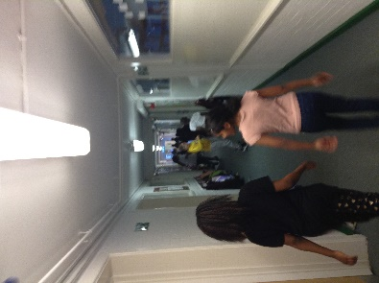 Andrea Okeke (left) and Nia (right) playing the treasure hunt game. Andrea Okeke (a student at the Becontree) weakly told us after the game that ‘I was gasping for water, I was so tired from all that water!’ Later on, the children had a break by having something to drink.
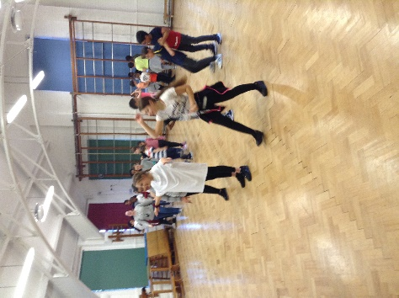 5R and 5W playing the team building game.

Minutes later, Miss Gaughran and Mrs Peters had told the year 5’s that they would go into the Junior Hall to play another game. We are not sure on what the game was called but a source had told us beforehand that the teachers had identified the game as a ‘Team building game’ First a bunch of cards were laid on the floor. Miss Gaughran enquired the children to stand by a card. After the instructions were explained, the children began playing. Andrea quoted ‘This was a pretty difficult game because we weren’t allowed to talk’

Finally, the year 5’s came back into the dinning hall to be welcomed by Maltesers, wine gums and many more snacks. Around 9:00 pm, the children geared up their torches ready to play hide and seek in the dark. Mrs Peters chose some seekers and then the children hid. Andrea Okeke told us that ‘I hid in 1D, this was very difficult because Aman (a student in the school) wouldn’t keep quiet! He was constantly singing ‘Old Town Road’ but later on, I was a seeker myself’ 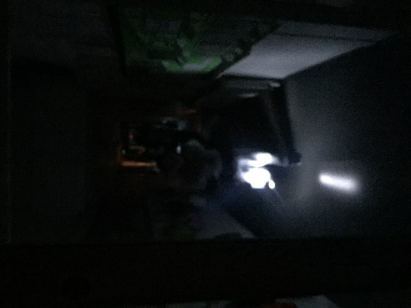 Children
playing Hide and seek in the dark.

Once they finished that’s when they approached the sunshine hall. It was time for them to watch a film. The teachers first put ‘The Bee Movie’ but apparently most of the kids have already watched it, so the movie was changed to ‘The Lorax’ a film based on a book by Dr Seues. As everyone was watching the film, Miss Gaughran had sent some groups to go and change into their pyjamas, brush their teeth and use the toilet. Whilst this was happening Miss Rushton and the other teachers handed out hot chocolate and popcorn. After the film was finished that’s when the lights were turned off and everyone was expected to sleep. It was rumoured that Mrs Ziane (the headteacher) was snoring in her sleep. She has denied the rumour

Once everyone woke up, it was time for everyone to get ready for home time. Many children and parents gave thanks to the teachers after an amazing sleepover.

