Year 5’s sleepover
On Friday 10th of May the year 5’s had a sleepover at their own school (Becontree Primary School). The year 5’s had a sleepover because they need to be prepared for a trip in year 6, Trewern.The teachers set up the sleepover for the year 5 kids and slept to. The teachers were Miss Rushton, Mrs Thorpe, Mrs Ziane, Mr Crowther, Mrs Peters. Mrs Thornton, Miss Gaughran and Mr Allen.

Dropped off and setting up
At 6:30pm the year 5’s were dropped off to the school office. The year 5 students sets out their sleeping bags in the Sunshine hall (Key stage one hall). When they finished setting up their comfortable beds, they have got ready for the treasure hunt. At the treasure hunt the teachers hid some sticky notes around the playground. The year 5 kids were set into groups and loudly tried to find the notes. Whatever group had the most notes gets to be the seekers for hide and seek.

Having more fun
After they finished the treasure hunt, they played team games. It’s really played like this, so they got into groups and played games. One game was when everyone had to pass a racket around with their feet. The year 5 children angrily, plays the game. Some children thought it might be easy but as they do it, it wasn’t. One group found it easy and tied up with another.

Darkness!
After all that fun, the year 5’s play one more game just before bedtime which is hide and seek. Not just an ordinary hide and seek, but one in the dark! Some children couldn’t wait to play. There were six searching seekers on the loose in the dark! The hiders were hiding very very very quietly. Poor Daniel was very scared at this game. Some hiders got away with it! Jesse kept on scaring people by jumping out of nowhere.

Lights off
As they finished playing hide and seek in the dark, the year 5’s got a lovely treat just before bed. Their treat was a movie and some hot chocolate! The movie was called The Lorax.As the movie ended the tired children had some nice hot chocolate. Daniel spilt his hot chocolate all over him! So, the teachers had to clean him all up. Everyone was so tired so they got ready for bed. The children head off to the bathrooms and brushed their teeth and splashed some water on their tired faces. As everyone finished brushing their teeth they changed up in their pyjamas and drifted into a deep, deep and quite sleep. Some kids might not wake up in the morning as they had a busy day and slept at 10:30 pm and wake up at 7:00am.

Leaving school
At 7:00am the tired year 5’s woke up. Sadly, it was time to go, so they got changed up and packed everything they had. The children had breakfast, had a wash and went to the office and went home.

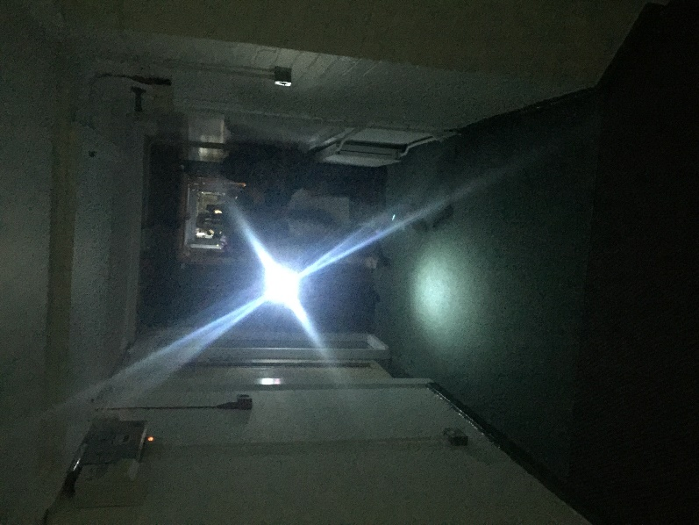
Thank you for all the teachers hard work!

