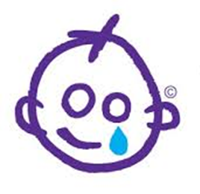
Sponsorship form

We are raising money for Great Ormond Street Hospital (GOSH) because they help families stay together when a child is very ill. We are doing a sponsored silly dance around Goodmayes Park on Tuesday 15th November and 1.30pm.

Name | Amount

