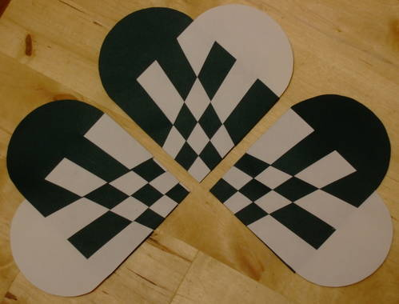
"Julehjerter" are traditional Danish Christmas decorations woven from paper. They can be filled with sweets or candies if desired or just hung on the tree or just about anywhere as decorations.
To make the process easier I've made printable pdf templates which can be printed onto A4 craft paper, getting rid of the boring part. The Basic Heart Template produces the hearts pictured in the step-by-step photo instructions, and the diagonal Heart template produces the hearts pictured above, but it's the same process used for each.
Basic Heart Template
Diagonal Heart Template
1.Print the basic heart template onto two contrasting coloured sheets of A4 paper, for the diagonal heart template print page 1 on one colour and page 2 on the other colour.
2.Cut along the black line to create 3 rectangular strips from each piece of paper
3.Fold along the dashed line
4.Then cut out along the lines to create a shape, consisting of a square with a semi circle at the end.
5.Cut along each black line to the line that runs along the top.
6.Unfold each shape, and refold so that the inside is now the outside so the printed lines will be hidden on the inside
7.Weave the strip from one side, between and then over the strips on the other side
8.Thread each strip in turn
9.Make sure the strips go through and over, not under and on top
10.As you get nearer the end, it gets trickier to thread the paper
11.The finished article, the final step is to attach a handle made of paper or string
12.The heart can be opened out and filled with sweets if desired or just hung on the tree.
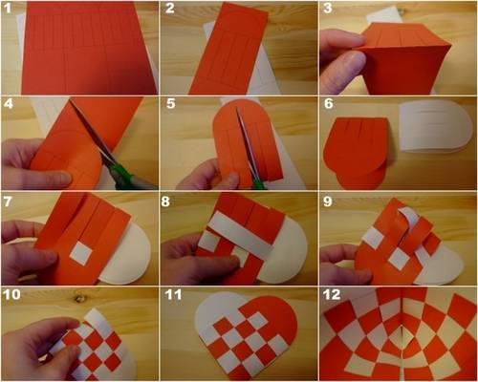
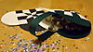

Central Star Template as pictured below


